由题得

1.E->aA 4.A->d

2.E->bB 5.B->cB

3.A->cA 6.B->d

因为第一个字符不需要扩展，所以直接进行规约，得出如下图所示

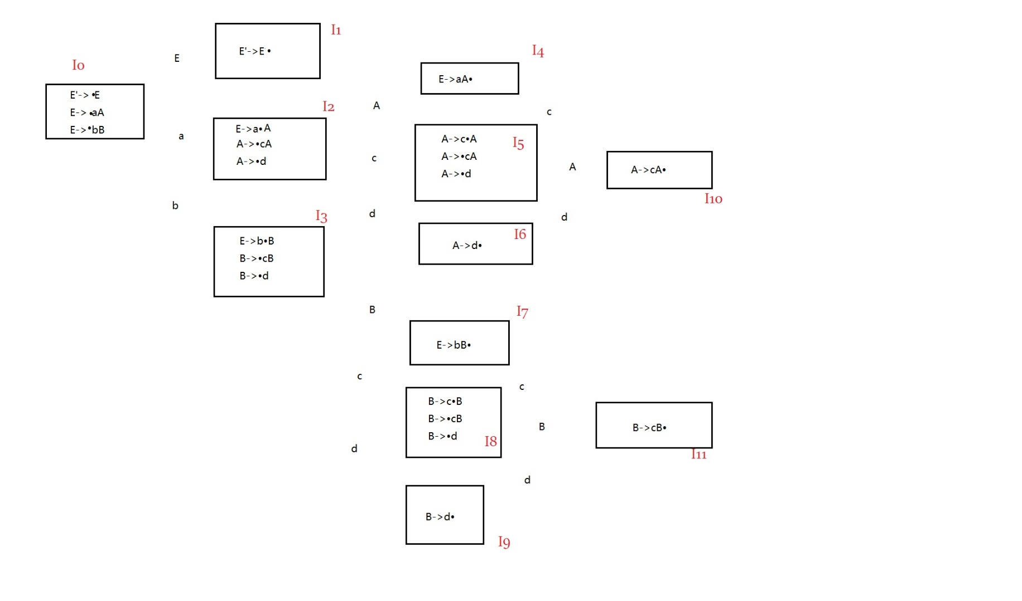



再构造分析表

|  |  |  |  |  |  |  |  |  |
| --- | --- | --- | --- | --- | --- | --- | --- | --- |
| 状态 | a | b | c | d | # | E | A | B |
| 0 | S2 | S3 |  |  |  | 1 |  |  |
| 1 |  |  |  |  | Acc |  |  |  |
| 2 |  |  | S5 | S6 |  |  | 4 |  |
| 3 |  |  | S8 | S9 |  |  |  | 7 |
| 4 | R1 | R1 | R1 | R1 | R1 |  |  |  |
| 5 |  |  | S5 | S6 |  |  | 10 |  |
| 6 | R4 | R4 | R4 | R4 | R4 |  |  |  |
| 7 | R2 | R2 | R2 | R2 | R2 |  |  |  |
| 8 |  |  | S8 | S9 |  |  |  | 11 |
| 9 | R6 | R6 | R6 | R6 | R6 |  |  |  |
| 10 | R3 | R3 | R3 | R3 | R3 |  |  |  |
|  |  |  |  |  |  |  |  |  |
| 11 | R5 | R5 | R5 | R5 | R5 |  |  |  |

分析acccd语句

|  |  |  |  |  |
| --- | --- | --- | --- | --- |
| 步骤 | 状态栈 | 符号栈 | 符号串 | 动作 |
| 1 | 0 | $ | Acccd$ | 2压入状态栈,a压入符号栈 |
| 2 | 02 | $a | Cccd$ | 5压入状态栈,c压入符号栈 |
| 3 | 025 | $ac | Ccd$ | 5压入状态栈,c压入符号栈 |
| 4 | 0255 | $acc | Cd$ | 5压入状态栈,c压入符号栈 |
| 5 | 02555 | $accc | D$ | 6压入状态栈,d压入符号栈 |
| 6 | 025556 | $acccd | $ | R4规约，状态栈和符号栈弹栈，各弹一位，规则左部A进栈，状态10进状态栈 |
| 7 | 0255510 | $acccA | $ | R3规约，状态栈和符号栈各弹两位。规则左部A进符号栈，状态10进状态栈 |
| 8 | 025510 | $accA | $ | R3规约，状态栈和符号栈各弹两位。规则左部A进符号栈，状态10进状态栈 |
| 9 | 02510 | $acA | $ | R3规约，状态栈和符号栈各弹两位。规则左部A进符号栈，状态4进状态栈 |
| 10 | 024 | $aA | $ | R1规约，状态栈和符号栈各弹两位，规则左部进符号栈，状态1进状态栈 |
| 11 | 01 | $E | $ | 接收acc,符号串是文法的句子 |

所以acccd是文法G[E]的句子